bug report: Malik

1. time frame selector:

In the section of time frame when a time is selected the next options get disabled when going back and when you click cancel reschedule.

* 1. Error producing:

In order to produce this error, you have to make a reservation and when you cancel the schedule the bug will appear. (sometimes the time also disappears)

1.2 Image bug preview:

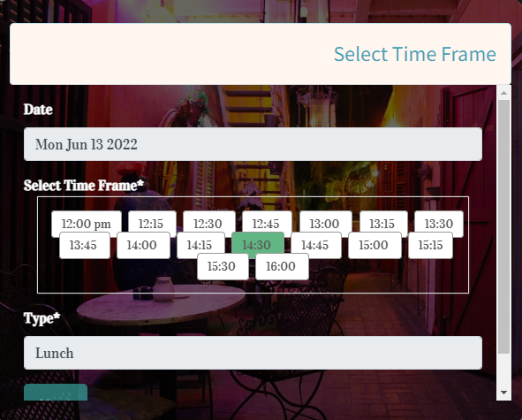

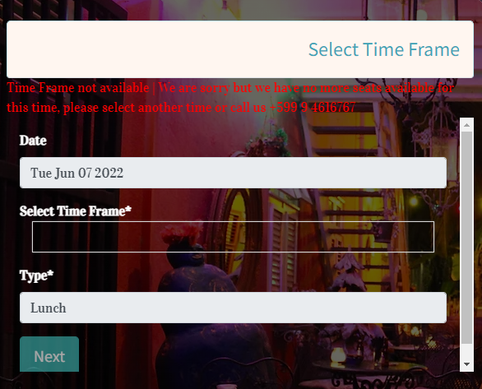

2.0